**Project Design Phase-II**

**Solution Requirements (Functional & Non-functional)**

|  |  |
| --- | --- |
| Date | 24 March 2025 |
| Team ID | PNT2025TMID06680 |
| Project Name | **Global Food Production Trends and Analysis A Comprehensive Study from 1961 to 2023 Using Power BI** |
| Maximum Marks | 4 Marks |

**Functional Requirements:**

Following are the functional requirements of the proposed solution.

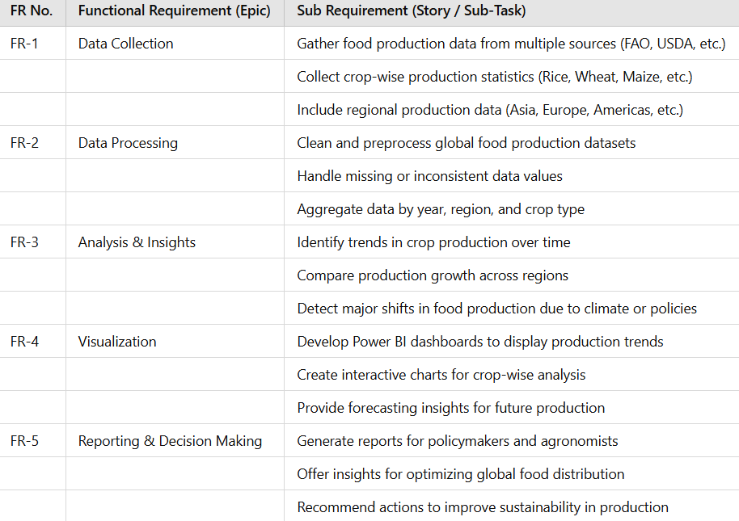

**Non-functional Requirements:**

Following are the non-functional requirements of the proposed solution.

|  |  |  |
| --- | --- | --- |
| **FR No.** | **Non-Functional Requirement** | **Description** |
| NFR-1 | **Usability** | Simple and intuitive UI/UX for non technical users |
| NFR-2 | **Security** | Implement authentication ,role-based access and data encryption |
| NFR-3 | **Reliability** | Ensure consistent data accuracy and uptime |
| NFR-4 | **Performance** | Dashboard should load with in 5 sec for large data set |
| NFR-5 | **Availability** | System should beavailable99.9% of the time |
| NFR-6 | **Scalability** | Support increase data volume and additional user without performance drops. |